Final Year Project Software Requirement Specification

For Project Title

Bachelor of Science in Software Engineering

By

|  |  |  |  |  |
| --- | --- | --- | --- | --- |
| S# | **Name** | **Registration #/Roll #/Section** | **Mobile #** | **E-Mail** |
| 1. | Faraz Khalil | Fa17 - BSSE - 158 | 03234114779 | [Fa17-bsse-158@lgu.edu.pk](mailto:Fa17-bsse-158@lgu.edu.pk) |
| 2. | Hafiz Ahmed | Fa17 - BSSE - 168 | 03214898395 |  |

**Supervised by:**

Miss Kiran Amjad

**(**Signature**)**



Department of Software Engineering Lahore Garrison University

Lahore

Table of Contents

1. Introduction. Page#

1.1 Purpose ........................................................................................................................

1.2 Document Conventions ................................................................................................

1.3 Intended Audience and Reading Suggestions ..............................................................

1.4 Product Scope ..............................................................................................................

2. Overall Description ...............................................................................................

2.1 Product Perspective......................................................................................................

2.2 Product Functions ......................................................................................................

2.3 User Classes and Characteristics ...............................................................................

2.4 Operating Environment ..............................................................................................

2.5 Design and Implementation Constraints ....................................................................

2.6 User Documentation ..................................................................................................

2.7 Assumptions and Dependencies ................................................................................

3. External Interface Requirements .......................................................................

3.1 User Interfaces ...........................................................................................................

3.2 Hardware Interfaces ...................................................................................................

3.3 Software Interfaces ....................................................................................................

3.4 Communications Interfaces .......................................................................................

4. System Features ..................................................................................................

4.1 System Feature 1 ........................................................................................................

4.2 System Feature 2 (and so on) .....................................................................................

5. Other Nonfunctional Requirements ...................................................................

5.1 Performance Requirements ........................................................................................

5.2 Safety Requirements ..................................................................................................

5.3 Security Requirements ...............................................................................................

5.4 Software Quality Attributes .......................................................................................

5.5 Business Rules ...........................................................................................................

References ....................................................................................................................

# Introduction

* 1. Purpose

This SRS Document is created for initial release of a mobile app project named casebook. Casebook is Lawyer’s portal app used to digitalize the lawyer’s work and cases and help provide better communication to the client’s with their lawyers. The document covers the complete project requirement, implementation, testing and deployment phase.

* 1. Document Conventions

This document is follow standard document conventions. Plain writing and fonts are are used in creating this document. No previous knowledge is assumed before reading this document.

* 1. Intended Audience and Reading Suggestions

This document is created for developers, stake-holders, designers, and other team members who are the part pf development process.

No particular sequence is intended in reading this document. The reader can jump to relevant section for he is using this document.

* 1. Product Scope

The main purpose of this software is to speed-up and digitalize the work of judicial system. The software will be used by lawyer’s and their clients to stay updated and to communicate better. It is aimed on replacing the file system of the courts.

# Overall Description

* 1. Product Perspective

The product is not a follow-up or any kind of plugin or component to any other product. The flowchart of the products basic functionalities is as follows:

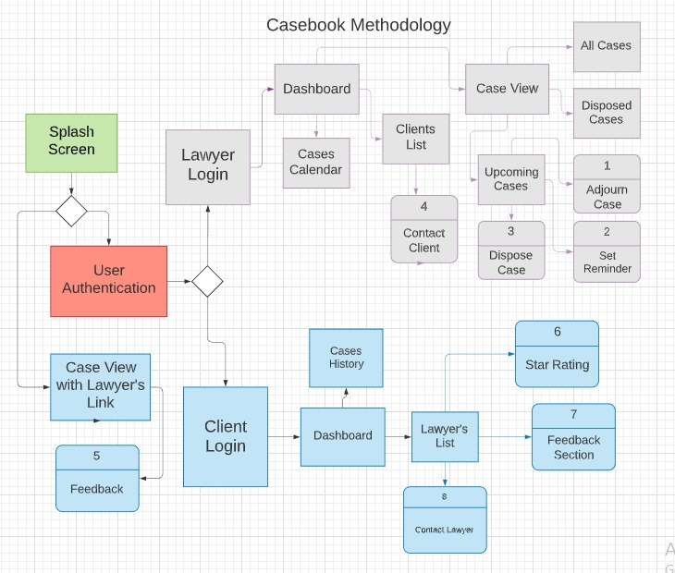

* 1. Product Functions

Following are the functions which the product offer its users to perform.

* User Authentication
* Cases Management
* Push notification
* Client side App
* Token based Case View
  1. User Classes and Characteristics

Primarily this app is made for the lawyers to manage the day to day works. The lawyers can add all their cases to a single platform online cloud based platform. Additionally the app also consist a client side where a client can mange all his cases with every lawyers with a simple signup or lawyer can let any client keep tab on his case without authentication with a single token based system.

* 1. Operating Environment

This project is a cross platform based mobile app built on React Native. It is using Expo-Cli Environment for development and is using no-sql cloud based database named Mongodb Cloud Atlas for data storing purposes.

* 1. Design and Implementation Constraints

The only limitation for the implementation of this project is it is being developed on a windows based machine which makes it impossible to develop a product for iOS platform, so a third party environment is used named ExpoCli in the development phase to make it possible to develop a cross platform app on a windows machine.

* 1. User Documentation

The whole documentation of the can be found on the playstore and appstore for help in usage of the application and the application itself also contains short tutorials for its new users to make it easier to get 100% benefit out of it.

* 1. Assumptions and Dependencies

The Product will use following dependencies during its development phase which cover both frontend and backend development of the project:

* Expo Cli
* Material UI
* Font Awesome
* React Bootstrap
* JSX
* Flaticons

# External Interface Requirements

* 1. User Interfaces

It follows a simple UI standards every functionality has a different UI after authentication the user can simply follow the steps to complete its tasks.

* 1. Hardware Interfaces

The hardware for the usage is an Android and iOS smart phone. It is a cross platform app so it can be used on both platforms to cover large number of audience.

* 1. Software Interfaces

These are the collective software interfaces which combines to make a complete product.

**React-Native:** A javascript based library created by facebook to make cross-platform apps with a single language.

**CloudFirestore:** A NoSQL cloud based database which store data in the form of collection and documents.

**ExpoCli:** A third party environment for react-native development in windows machine.

**React-Bootstrap:** A CSS library for react to make beautiful user-interfaces.

**React-Icons:** A react library for importing icons to the projects.

**JSX:** A react component to make user-interfaces in javascript using html, xml and swift like tags.

* 1. Communications Interfaces

This product uses following communication and security standards.

* Firebase Authentication: for user authentication.
* Http Request: Api integration for any third party services.
* Firebase offline persistance: for apps offline usage.
* Push Notifications: Firebase push notifications.
* OTP service: Firebase One time password for additional security.

# System Features

The product offers multiple features for the aid of its users, Here are the features defined one by one in terms of lawyers and clients.

* 1. System Feature 1

Cases Management fro lawyers.

* + 1. Description and Priority

Case can be saved by lawyers and app will notify the user on time of the hearing.

* + 1. Stimulus/Response Sequences

User will be notified on every upcoming case by the app.

* + 1. Functional Requirements

This feature require following functional requirments

* Cloud Firestore
* Firebase Cloud Messaging
* Firebse Authentication
* Apple Push Notification Services
  1. System Feature 2

Client’s side of application

4.2.1 Description and priority

Lawyers can let the clients to see their cases.

Client can save their cases.

Clients can watch the cases history.

4.2.2 Stimulus/Response Sequences

Client will get a token from his lawyer to view his case if don’t want to signup he can still stay updated to his cases.

4.2.3 Functional Requirements

This feature depends upon these functional requirements.

* Cloud Firestore
* Firebase Authentication

# Other Nonfunctional Requirements

* 1. Performance Requirements

One of the major functionalities of the product is to make better communication between lawyers and clients so the good performance is a key role of the application.

* 1. Safety Requirements

As it consists of sensitive information about the lawyers or clients. It is very serious about the security concerns. The database used in this product is Google’s Cloud Firestore which is a cloud based and one the best databases existed. And also provides advanced security and encryption services.

* 1. Security Requirements

Casebook uses Firebase Authentication for authenticating users which covers all the security concerns for the database.

* 1. Software Quality Attributes

The product is easy to use and adapt as it will be mostly used by less technical people who don’t have regular interaction with technology.

It has an easy and less complicated interface for low learning curve.

It has a cloud based database for advanced storage and security purposes.

* 1. Business Rules

Lawyers can use this application during their work. They can manage their day to day job through this application. They can save their hearings, their adjourn dates and keep their clients updated.

The clients can also save their cases

# References

* <https://reactnative.dev>
* <https://material-ui.com>
* <https://play.google.com/store/apps/details?id=com.pathlegal.app&hl=en&gl=US>